INSTRUCTIONS

- Read the extracts and questions carefully.
- Number your answers exactly as the questions are numbered.
- Leave a line between each answer.
- Draw a right-hand margin.
- It is in your own interests to write legibly and to present your work neatly.

QUESTION ONE 30 MARKS
COMPREHENSION

Read the TEXT below and answer the questions which follow.

1 It's the national religion. Transcending race, politics or language group, sport
unites the country – and not just the male half of it.
2 When a South African team wins, a cacophony of hooting, cheering, banging
of dustbin lids, trumpeting on cow horns and fireworks reverberates across
the largest cities. The national adrenaline goes into overdrive. Maybe even
the Gross Domestic Product goes up. Just don't look too cheerful on the
Monday morning after a dismal sporting weekend! Sport, like no other South
African institution, has shown it has the power to heal old wounds. When the
Springboks won the Rugby World Cup on home turf in 1995, Nelson Mandela
donned the No. 6 shirt of the team's captain – Francois Pienaar, a white
Afrikaner – and the two embraced in a spontaneous gesture of racial
reconciliation which melted hearts across the country.
3 A single moment, and 400 years of colonial strife and bitterness … suddenly
seemed so petty.
4 It wasn't always that way. During the apartheid era, racially segregated sport
was a highly divisive issue, as exemplified by the case of Cape Town
cricketer Basil D'Oliviera, a world-class talent who just happened to have the
'wrong' colour of skin. Disqualified from local first-class cricket on the grounds
of race, D'Oliviera went to live in England in 1960, becoming one of the stars
of the English team. When he was selected for a 1968 tour of South Africa,
the apartheid government barred him – an act of folly that offended even the
crustiest British conservatives, and turned South Africa into an international
sporting pariah.
5 But it was a sporting moment that first helped to heal the country's racial rift.
In 1992, the country returned to the Olympics for the first time since it was
barred 32 years earlier. In the women's 10 000 metre finals in Barcelona, two
runners dominated the field, running shoulder to shoulder, lap after lap, way
ahead of the field. One was South African Elana Meyer; the other was
Ethiopian Derartu Tulu. With just metres to go, Tulu found the strength to
'kick' ahead of Meyer and become the first African woman to win a major
Olympic titel. But the big moment was to follow, when Tulu and Meyer
embraced, then ran a lap of honour together, each draped in her country's
national flag, a white Afrikaner and a black African together, cheered on by
the crowds.
6 The major sports in which South Africa excels are the aristocratic British
games of rugby and cricket. For over a century, the country has regularly
fielded teams of world-beating class, playing chiefly against arch-foes
England, Australia and New Zealand.
7 Thirty years of apartheid isolation did some damage, yet despite many

international dissapointments, both teams have risen to the occasion since
South Africa's readmission to international sport in 1992, winning honours
against the world's toughest opposition.
8 But it is football – or soccer, as it is universally called here – that has won the
hearts of South Africa's black majority. South Africa is by no means a giant in
the world of soccer, but for many black South Africans, the country's proudest
sporting moment came when it won the African Nations Cup on home turf in
1996 – having failed to even qualify for the previous cup. Soccer is intensely
followed, and the quality of the local game keeps improving – as is
demonstrated by the increasing number of South African players-in-exile
among the glamorous European clubs. The national team, nicknamed
Bafana Bafana, which means 'The Boys', is extraordinarily erratic, beating
giants, then succumbing to minnows.
9 Local teams, organised in a national league plus a plethora of knock-out
cups, are followed with the same passion as in many other countries, by
paint-daubed, costumed, whistling and cheering fans. Mercifully, the country
has been spared the spectre of football hooliganism.
10 The list of South African sporting achievements goes wider than the 'big three'
sports, however. In a country of magnificent golf courses, for example, it is not
surprising that South Africa has bred some world-beating stars, from Bobby
Locke in the post-World War Two period to Gary Player – who walked away
with more international trophies than arch-rival Jack Nicklaus – to new stars
Ernie Els, Retief Goosen, Trevor Immelman and others. South Africa has
also bred world champions among our swimmers, athletes, surfers, boxers,
tennis players and more.

SOURCE: Adapted from www.sfrica.info/about/sport/sportsa.htm

DEFINITIONS

pariah: an outcast; someone generally despised or rejected

QUESTIONS

  - Refer to paragraph 1.

1.1.1 What do you understand by the reference to sport as a national religion? (2)
1.1.2 What stereotype is referred to in paragraph 1. (1)

1.2 Refer to paragraph 2.

1.2.1 Describe how South Africans tend to react to sporting victory. (2)
1.2.2 Suggest why the writer issues the warning, Just don't look too cheerful on the Monday morning after a dismal sporting weekend! (2)
1.2.3 How, in your opinion, can sport heal old wounds? (2)

1.3 Explain the significance of pointing out that 400 years of colonial strife and bitterness … suddenly seemed so petty (paragraph 3). (2)
1.4 Do you think that the placing of inverted commas around wrong (paragraph 4) is appropriate in the way it has been used in the passage? Explain your answer. (2)

1.5 What does When he was selected … crustiest British conservatives (lines 20–22) suggest about the difference between British and South African
conservatives at the time? (2)

1.6 Paragraph 5 and paragraph 7 each contain a spelling error. Identify and correct these errors. (2)

1.7 What does the nickname of the South African national soccer team, Bafana
Bafana or The Boys (paragraph 8), imply about the attitude of soccer fans to the team? (2)
1.8 How does the expression players-in-exile (paragraph 8) manipulate the readers’ impression of South African players who play for European teams?
(2)
1.9 Explain why the statement, South Africa is by no means a giant in the world of soccer (paragraph 8), is an example of a euphemism. (2)

1.10 Does the word plethora, as it is used in paragraph 9, have negative or positive connotations? Provide a reason for your answer. (2)

1.11 Explain how the thirty years of apartheid isolation damaged sport in South Africa. (2)

1.12 Which sports are considered to be the big three? (3)

[30]

QUESTION TWO 10 MARKS
SUMMARY

Carefully read the TEXT below. It discusses the nature of positive thinking and people’s attitudes towards it.

Using the ideas mentioned in the passage, write a persuasive speech in which you explain the advantages of positive thinking.

- Your summary may not exceed 90 words.
• You must write ONE fluent paragraph.
• You are required to include a title (included in the word count).
• Indicate your word count at the end of your summary.

THE POWER OF POSITIVE THINKING

Positive thinking is a mental attitude that admits into the mind thoughts, words and images that are conducive to growth, expansion and success. It is a mental attitude that expects good and favourable results. A positive mind anticipates happiness, joy, health and a successful outcome of every situation and action. Whatever the mind expects, it finds.
Not everyone accepts or believes in positive thinking. Some consider the subject to be just nonsense, and others scoff at people who believe and accept it. Among the people who accept it, not many know how to use it effectively to get results. Yet it seems that many are becoming attracted to this subject, as evidenced by the many books, lectures and courses about it. This is a subject that is gaining popularity.
It is quite common to hear people say: 'Think positively!' to someone who feels down and worried. Most people do not take these words seriously, as they do not know what
they really mean, or do not consider them to be useful and effective. How many people do you know, who stop to think what the power of positive thinking means?
All of us affect, in one way or another, the people we meet. This happens instinctively and on a subconscious level, through thoughts and feelings transference, and through body language. People are affected by our thoughts, and vice versa. Is it any wonder that we want to be around positive people and avoid negative ones? People are more disposed to help us if we are positive, and they dislike and avoid anyone broadcasting negativity.
When the mind is negative, negative poisons are released into the blood, which causes more unhappiness and negativity. This is the way to failure, frustration and disappointment. Always visualise the favourable and beneficial situations. Use positive words in your inner dialogues or when talking with other. Smile a little more, as this helps one to think positively. Disregard any feelings of laziness or a desire to quit. If you persevere, you will transform the way your mind thinks.
[Source: Adapted from an article by Remez Sasson on www.positivethinking.com]

QUESTION THREE 30 MARKS
POETRY

3.1 SEEN POETRY

Read the following poem and answer the questions which follow.

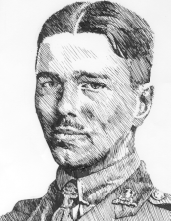
DULCE ET DECORUM EST
Bent double, like old beggars under sacks,
Knock-kneed, coughing like hags, we cursed through sludge,
Till on the haunting flares we turned our backs
And towards our distant rest began to trudge.
Men marched asleep. Many had lost their boots 5
But limped on, blood-shod. All went lame; all blind;
Drunk with fatigue; deaf even to the hoots
Of tired, outstripped Five-Nines that dropped behind.
Gas! Gas! Quick, boys! – An ecstasy of fumbling,
Fitting the clumsy helmets just in time; 10
But someone still was yelling out and stumbling,
And flound'ring like a man in fire or lime . . .
Dim, through the misty panes and thick green light,
As under a green sea, I saw him drowning.
In all my dreams, before my helpless sight, 15
He plunges at me, guttering, choking, drowning.
If in some smothering dreams you too could pace
Behind the wagon that we flung him in,
And watch the white eyes writhing in his face,
His hanging face, like a devil's sick of sin; 20
If you could hear, at every jolt, the blood
Come gargling from the froth-corrupted lungs,
Obscene as cancer, bitter as the cud
Of vile, incurable sores on innocent tongues,
My friend, you would not tell with such high zest 25
To children ardent for some desperate glory,
The old Lie; Dulce et Decorum est
Pro patria mori. WILFRED OWEN

QUESTIONS

3.1.1 Explain the irony in the title of the poem. Your answer must include a discussion of the title, as well as the content of the poem. (3)

3.1.2.1 What is the physical condition of the soldiers described in stanza one? Quote to support your answer. (2)
3.1.2.2 How does this description position us to view war? (2)
3.1.3 How does the use of punctuation in stanza two reinforce the horror of the gas attack? (3)

3.1.4 What effect does the gas attack have on the speaker of the poem? Support your answer with evidence from the poem. (3)

3.1.5 Discuss the connotations of the word flung as it is used in line 18. (2)

3.1.6 Explain the effectiveness of the simile in line 20. (3)

3.1.7 Provide TWO adjectives of your own to describe the speaker’s tone in lines
25 – 28. (2)
[20]

3.2 UNSEEN POETRY

Read the poem below and answer the questions that follow.

ODE TO AN ORANGE – ANDRE VAN VUUREN
I stand here with a sliver
of the african sun in my hand
colourful, firm and full of
promises, waiting to be explored
for its delights: 5

to gently part the flesh
from its bright and fragrant skin
and its sweetness will linger on in
my mouth like my first teenage kiss

I tremble before the fading 10
memory of this delightful dream
that sprung from our fertile african soil …

3.2.1 Explain the extended metaphor used in this poem. (2)

3.2.2 Why would the poet compare the eating of an orange to his first teenage kiss in line 9? (2)

3.2.3 An ode is a song. Bearing the title in mind as well as the content of the poem, how does the following visual help us understand the poet’s view of Africa in this poem? (3)
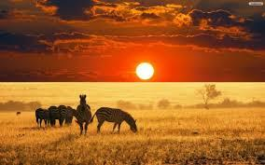

3.2.4 Examine the words “tremble” and “fading memory” in lines 10 and 11. How do these words indicate a change in the poet’s perception of Africa? (3)

[10]

QUESTION FOUR 20 MARKS
VISUAL LITERACY

Study the advertisement and answer the questions which follow.

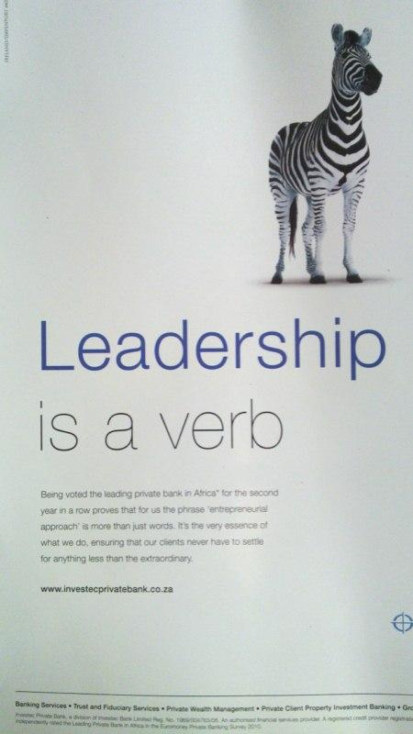

QUESTIONS

4.1 To whom would this advertisement appeal? Support your answer by referring to the information provided in the advertisement. (2)

4.2 Investec’s slogan is: 'Out of the Ordinary'. Explain whether this slogan is justifiable in terms of a claim made elsewhere in the text about the service being advertised. (2)

4.3 Comment on the effectiveness of the statement, 'Leadership is a verb', as an
advertising device. (3)

4.4 Do you think the visual image is suitable for the service being advertised?
Justify your answer. (3)
[10]

Study the Madam and Eve cartoon and answer the questions below.

Madam and Eve

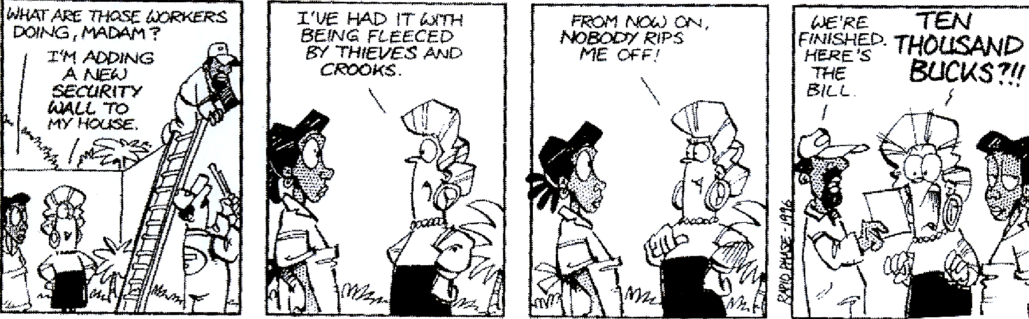
FRAME 1 FRAME 2 FRAME 3 FRAME 4
[Source: www.cartoonstrips.co.za]

QUESTIONS

4.5 What do Madam's facial expression and body language reveal about her feelings towards the new wall in frame 1? (2)

4.6 Refer to frame 2.
What do the idiomatic expressions, 'I've had it' and 'being fleeced', convey about Madam's attitude towards crime? (2)

4.7 Explain how the bill, presented to Madam in Frame 4, creates humour in the cartoon. (2)

Refer to the Andy Capp and answer the questions below.
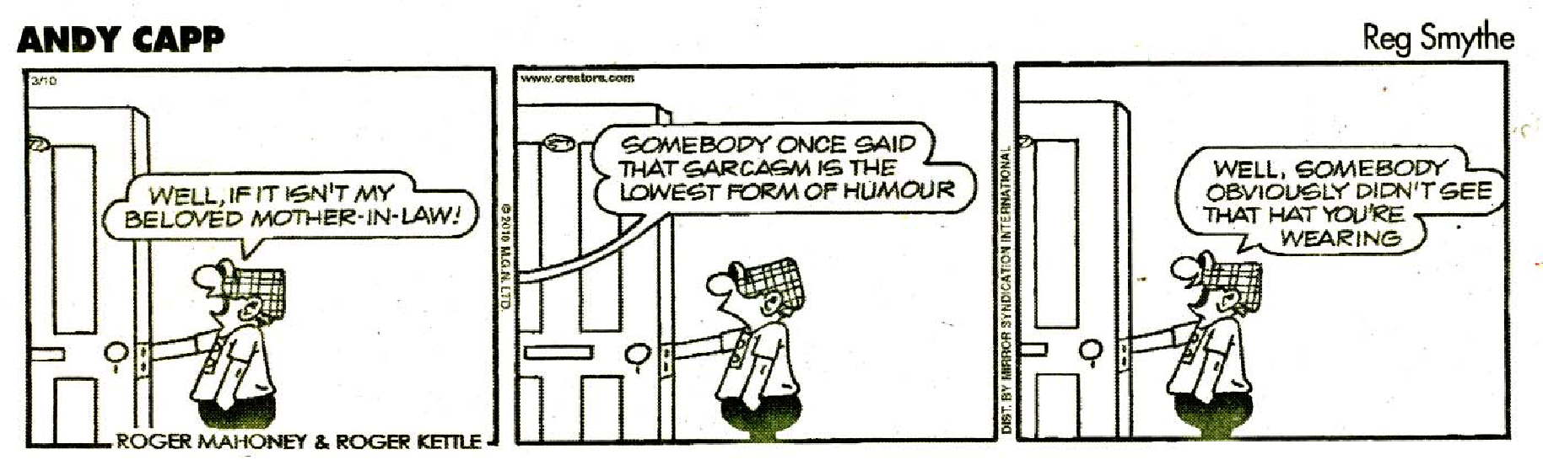
FRAME 1 FRAME 2 FRAME 3
[Source: The Star, July 2011]

QUESTIONS

4.8 Refer to frame 2.
Why does the mother-in-law accuse Andy of sarcasm? (2)

4.9 The cartoonist does not show the mother-in-law in any of the frames. Do you think that this is an effective technique? Motivate your response. (2)
[10]

